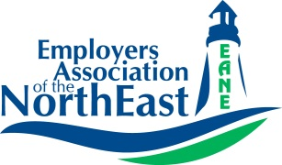

Human Resource Business Partners

Employers Association of the NorthEast (EANE) has Part-Time openings for dynamic, motivated HR Generalists to provide diversified human resource services to our membership organizations. For some members, we support and augment their current HR team and for others, we ARE their HR department! Our team of professionals, consult, problem solve, provide resources, develop solutions, educate, and enhance the skills, knowledge and competencies of the member organizations we serve. At EANE, we help create engaged, well-managed and low-risk workplaces for the organizations we work with.

Many of our member companies require assistance onsite on a project basis. If you’re seeking an opportunity to utilize your talent and extensive HR experience, and want to work a Part-Time schedule, this may be the opportunity for you! Projects range from tactical to strategic HR assignments where you are a key extension of our member’s team onsite. This unique role requires the ability to adjust and adapt to a wide variety of cultures and work environments and develop credibility and rapport at all levels of an organization rapidly.

All candidates should have a minimum of 5 to 7 years of experience as an HR Generalist with a strong background in state and federal employment laws and regulations. Day travel within RI is also required. PHR, SPHR, or SHRM certifications are a definite plus.

At EANE, you can use your current capabilities to work on projects in almost every area of HR while developing your skills and broadening your own experience. If you have strong communication, writing, project management and interpersonal skills, and enjoy being in a team environment where no two days are alike, we would like to talk with you!

Interested professionals should send their resume and cover letter to Pam Thornton, pthornton@eane.org, or mail to EANE, PO Box 1070, Agawam, MA, 01001-6070.
To learn more about EANE visit our website at www.eane.org

An Equal Opportunity Employer

