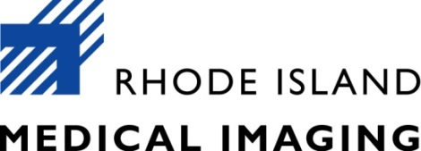

Human Resources Manager - Full-Time Exempt Position
Located in new corporate headquarters in Warwick, RI

Under the general supervision of the Director of HR this position guides and manages the overall provision of Human Resources services, policies, and programs for Rhode Island Medical Imaging. This is a working manager role supervising two staff members and also responsible to administer and oversee recruiting and staffing; employee onboarding practices, employee engagement and development, staffing needs assessment; training and compliance; employee safety, wellness; compensation and benefits administration; corrective action plans and employee termination protocols.

Emphasis on experience in compensation programs and analysis is preferred.
Salary based upon experience.

SKILLS AND ABILITIES REQUIRED

- A bachelor's degree and a minimum of seven years of progressive leadership experience in Human Resources positions preferred
- Supervisory experience required
- Outstanding interpersonal relationship building and employee coaching skills
- Demonstrated ability to lead and develop HR staff members
- Excellent computer skills in a Microsoft Windows. Must include knowledge of Excel and skills in Human Resources Information Systems (HRIS)
- Experience in the administration of benefits and compensation programs
- Knowledge of payroll and time and attendance systems
- Excellent organizational management skills and above average written and spoken communication skills.
- Ability to multi-task is required
- SHRM Certification preferred

About Our Company

Rhode Island Medical Imaging (RIMI), one of the largest radiology groups in New England. Established in 1943 and recently named one of the first outpatient diagnostic imaging Centers of Excellence by the American College of Radiology, RIMI prides itself in maintaining the highest standards of practice in diagnostic imaging. Through a growing network of private facilities located throughout the state of RI, our staff of radiologists, registered technologists and office personnel are able to provide a full range of diagnostic imaging procedures including x-ray, computed tomography, mammography, ultrasound, interventional and vascular radiology as well as magnetic resonance imaging. RIMI has an academic commitment to The Warren Alpert Medical School of Brown University School of Medicine and interprets imaging examinations at Rhode Island/Hasbro Childrens' Hospitals, Women & Infants Hospital, The Miriam Hospital, Fatima Hospital and Roger Williams Medical Center.

Please send resumes to Susan Logan @ slogan@rimirad.com.

