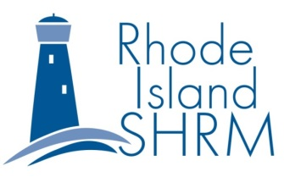
RI-SHRM
Volunteer Leaders Conference
Wednesday, October 2, 2019
2 – 5:15 p.m. Conference
5:15 – 7:00 p.m. Networking, Beverages and Snacks

Save The Bay
100 Save The Bay Drive
Providence, RI 02905

Welcome and Announcements Cindy Butler
State Chapter Director, RI SHRM

SHRM National Updates Susan Post
Field Services Director, SHRM

Volunteer Recognition Lynn Corwin
Director, Operations, RI SHRM
Break

Keynote: Self Reflection and Cortney Nicolato,
Personal Leadership President & CEO
United Way of Rhode Island

PANEL: Assessments – Which One is Jackie Dube, The Predictive Index
Right for You and Your Organization Mike Ritz, Leadership Rhode Island
And When? Michelle Saunders, IGT

Wrap Up/Closing Megan Herne
Programs, RI SHRM

Networking Reception All

